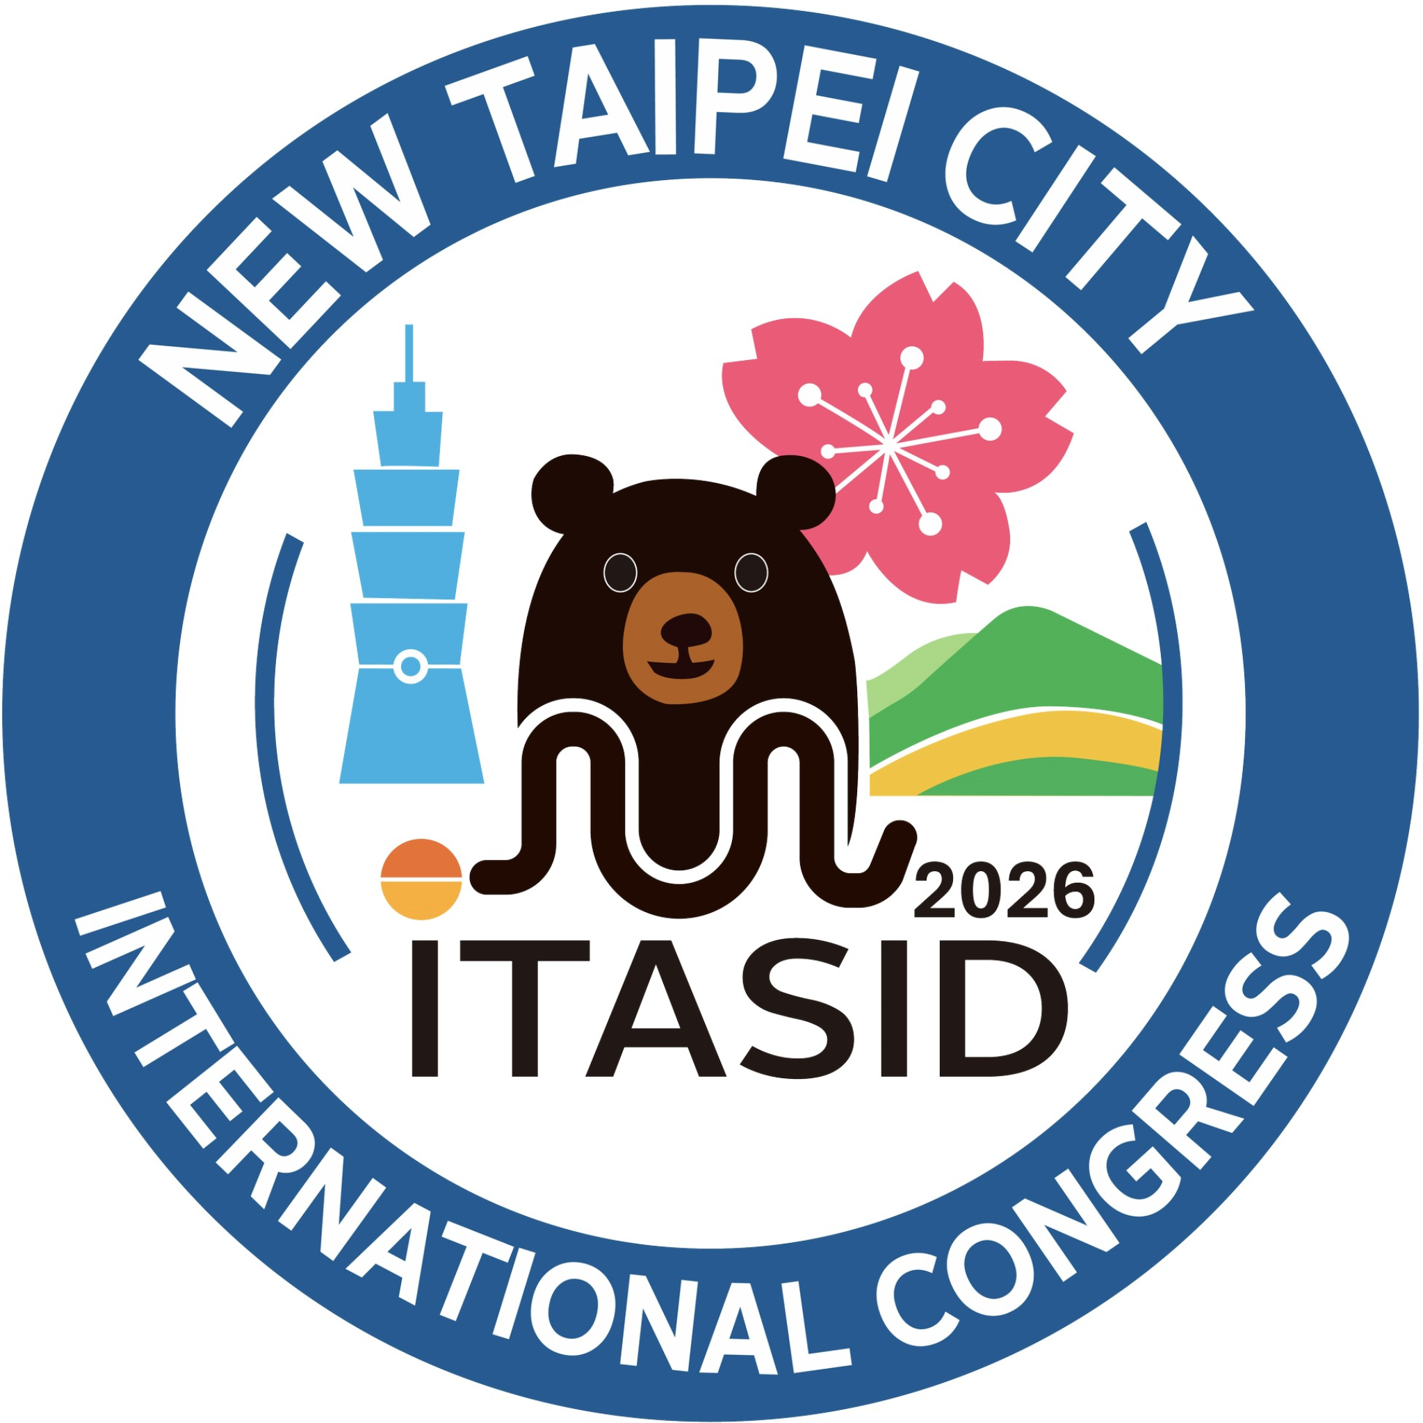 | 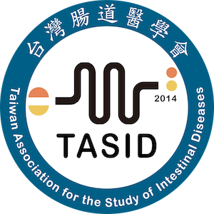
iTASID 2026 TRAVEL GRANT APPLICATION

TRAVEL GRANTS FOR INTERNATIONAL PARTICIPANTS
Two (2) Travel Grants will be awarded to international participants traveling from outside Taiwan.
Each award includes USD 500 travel support.
APPLICANT INFORMATION
Full Name: __________________________________________________ Title: ☐ Prof ☐ Dr ☐ Mr ☐ Ms
Institution: __________________________________________________
Department: __________________________________________________ Current Position: __________________
Country: __________________ Email: ____________________________ Mobile / WhatsApp: ______________
ABSTRACT INFORMATION
Submission Number: __________________________________________ Presentation Type: ☐ Oral ☐ Poster
Role in Abstract: ☐ Presenting Author

Abstract Title: _________________________________________________________________________________________________________
ELIGIBILITY CHECKLIST
☐ Submitted an abstract to iTASID 2026 ☐ Completed online registration
☐ Enclosed Curriculum Vitae (CV) ☐ Completed this Travel Grant application form
☐ Only applicants with accepted abstracts will be considered

CAREER STAGE
☐ Student/Trainee ☐ Early Career Investigator (<5 yr) ☐ Faculty / Consultant

IMPORTANT DATES
Application Deadline: March 22, 2026 Notification of Successful Applicants: By April 6, 2026
SUBMISSION
Submit to: tasidmail@gmail.com Required: CV and this Application form
DECLARATION
I certify the information is accurate. Award requires ACCEPTED abstract and PRESENTATION at the meeting.

Applicant Signature: _________________________________________ Date: __________________

